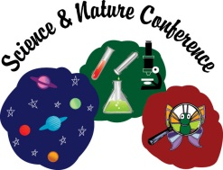
Science & Nature Conference
May 7, 2024
Presenter- Survey

Please remember to turn in your name badge

This survey is also online if that is easier for you. http://www.swwc.org/sn

How do you feel your sessions went?

Do you feel the kiddos caught on and understood what they needed to do in your session?

Did you have a good experience or moment with the kids you can share (connection or break through)?

Are there areas we could make improvements?

Do you have other topic ideas for yourself or others?

Do you have potential presenter suggestions with contact info (can be self-taught, teacher, professional, someone who works well with kids?

Would you be interested in presenting again?

Other comments

Please return to:
Andrea Anderson
SWWC Service Cooperative
1420 E. College Drive
Marshall, MN 56258

